CLAIM REPORT
ORDER Nº – JCB2401170
CUSTOMER – JC/TL BALL VALVE CORPORATION AD Ref. JCTL-9336
PART – 6030AICG250LPT
SERIAL Nº – 1-248966-3

1-BACKGROUND

On last 13th January of 2025, a refurbishment of the above-mentioned part number, has been requested by – JC/TL BALL VALVE CORPORATION with reference order JCTL-9336 and introduced as renewal devolution/maintenance service on JC Fábrica de Válvulas with trace code JCB0125SRH00002 and order JCB2500130.

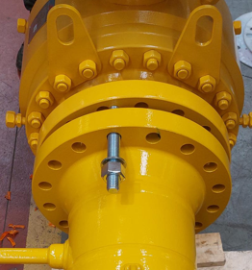 | 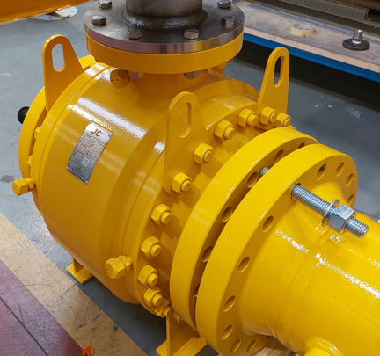
ASSEMBLY VALVE ON CUSTOMER’S WORKSHOP

2. - ACTIVITIES CARRIED OUT

The following activities have been carried out for the reconditioning/repair of the valve:

- Dimensional quality control of the reported defect.
- Confirmation of the hole misalignment due to wrong machining on a body connector unit.
- Disassembly of the valve parts required to replace the defective body connector with a new one.
- Assembly and leakage test of the valve without actuator.
- Validity of leakage test results according to EN 12266-1/API 598 (See attached report no. RS-250116-PPS in this statement)
- Assembly the actuator on the valve.
- Final quality control of the valve.
- Packaging and management shipment to the customer.

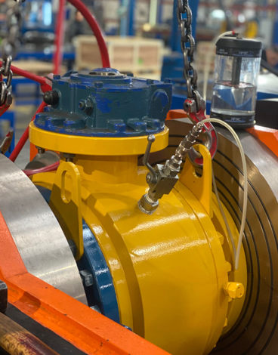 | 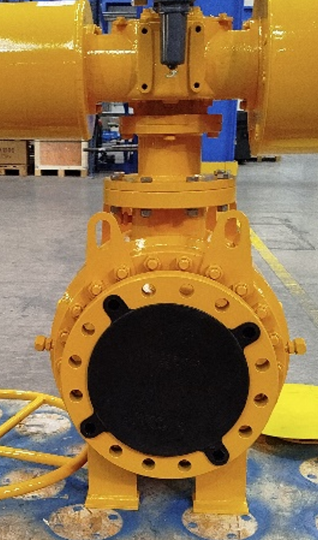
PNEUMATIC AIR TEST | FINAL QUALITY CONTROL

3-FINAL RESULTS

The valve has passed satisfactory all the test carried out without signs nor traces of fail or inappropriate functionality.
The customer has been informed by email of the processes carried out during the repair and the expected delivery date of the valve to its facilities next 20th January of 2025.
Finally, JC considers this complaint / repair order to be satisfactorily closed.

Report Issued By:
Ethan Martos
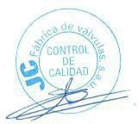

After Sales Service - JC Fábrica de Válvulas

